Line Test Results for CAM 3 (NIGHT) :-   
  
These tests are done for 3 kind of defects in Cam 3 images:-

* Short Mitre - defective or non_defective ( 2 classes)
* Long_Mitre - defective or non_defective ( 2 classes)
* Top Lid – blank, defective or non_defective ( 3 classes)  
  Test was done on 12568 images from 11.12 pm - 2.08 am

A)

SHORT MITRE

Defective Predicted were 92 items :

Correct predicted 5 Long seam defective(took as defective) 36 Camera errors 5

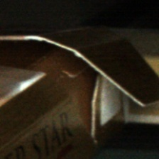  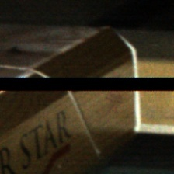

Double packet with fishmouth in prev.(6) False Detection 40

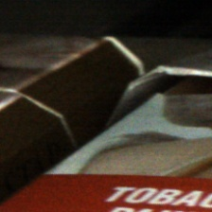 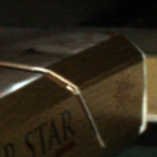

B) LONG_MITRE

Defective Predicted (37 items)

Correct Predicted 33 Camera Error 3 False detection 1

 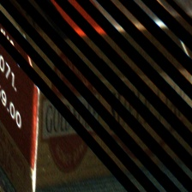   
  
  
c) BOTTOM LABEL

Blank predicted 0 (i.e, no print on bottom panel)

Defective predicted 48

Correct prediction 1 Very less long seam defect captured 4 Camera error 3

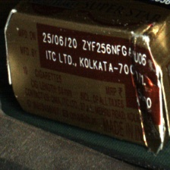 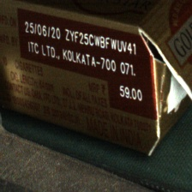 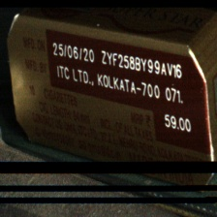

False detection 40

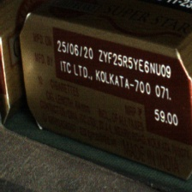

Line Test Results for CAM 3 (DAY) :-   
Test was done on 9697 images from 10.00 am - 2.24 pm

A)

SHORT MITRE

Defective Predicted were 253 items :

Correct predicted 10 Long seam defective(took as defective)13 Camera errors 12

 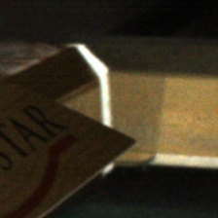 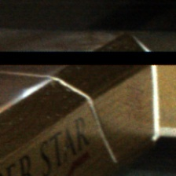

Double packet with fishmouth in prev.(3) Error in capturing 198 ( a packet was on top of another and trigger continued to give image )

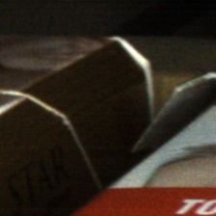 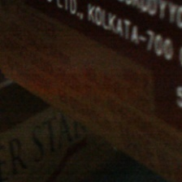

False detection 19



B) LONG_MITRE

Defective Predicted (25 items)

Correct Predicted 16 Camera Error 5 False detection 4

  

c) BOTTOM LABEL

Blank predicted 2 (i.e, no print on bottom panel)

Both camera error

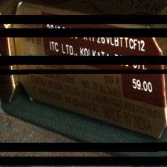

Defective predicted 33

Correct predicted 1 Camera error 16 Miscellaneous 1 Miscellanoeus3

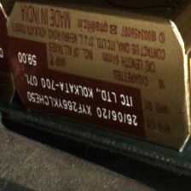 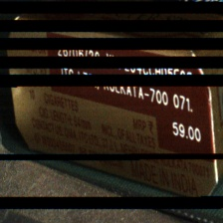 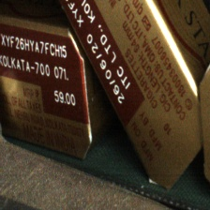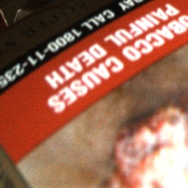

False detection 12

